**W4 -** PRACTICE

*JS – ES6 Functions*

## *At the end of this practice, you should be able to…*

* Use function **default argument**
* Use **arrow functions**
* Pass **function as a parameter**
* Use **Destructuring syntax**
* Use **spread syntax** to clone objects

## *How to work?*



**BEFORE THE PRACTICE**

* First watch and understand the **following pages and videos**:

[Function basics](https://developer.mozilla.org/en-US/docs/Web/JavaScript/Reference/Functions), [default parameter](https://developer.mozilla.org/en-US/docs/Web/JavaScript/Reference/Functions/Default_parameters), [arrow function](https://developer.mozilla.org/en-US/docs/Web/JavaScript/Reference/Functions/Arrow_functions), [destructuring](https://developer.mozilla.org/en-US/docs/Web/JavaScript/Reference/Operators/Destructuring_assignment), [spread operator](https://developer.mozilla.org/en-US/docs/Web/JavaScript/Reference/Operators/Spread_syntax)

[Video 1](https://www.youtube.com/watch?v=HFaxylC7bUc),

* Then complete the **following quiz** (*you can re-do it until you have 100% score*)

<https://forms.gle/FtUHEsoRnV8eBsTx7>

**DURING THE PRACTICE**

* To start the practice. **download the start code** from Google classroom

## *How to submit?*

* **Create a repository on GitHub** with the name of this practice:

Ex: C1-S2-PRACTICE

* **Push your final code** on this GitHub repository (if you are lost, [follow this tutorial](https://www.datacamp.com/tutorial/git-push-pull))
* Finally, submit on **Google classroom** your GitHub repository URL

Ex: https://github.com/thebest/ C2-S1-PRACTICE.git

# UNDERSTAND THE CONCEPTS…

Before starting exercises, explain - *in your own words* – the benefit of some concepts in JS

|  |  |
| --- | --- |
| **What is the benefit of** | **You explanation** |
| Benefit of function **default argument** | *Function default arguments allow us to assign a default value to a function parameter.* |
| Benefit of **arrow functions** | *The arrow function’s concise syntax eliminates the need for the function keyword and curly braces for single-line expressions.* |
| Benefit of the **destructuring syntax** | *Destructuring syntax allows us to extract values from arrays or objects easily.* |
| Benefit of the spread operator | *The spread operator (...) allows us to easily copy, merge, or pass elements from arrays or objects.* |

# EXERCISE 1

In the provided code, there's an array named shoppingCart representing a user's shopping cart with items containing 'name', 'price', and 'quantity' properties.

The current code calculates the total price of items in the shopping cart without using functions.

**THE PROBLEM**

This code works only for this specific shopping cart. But we want to be able to compute the total price for any shopping cart

**YOUR JOB**

Your task is to refactor the code by extracting the logic for calculating the total **price into a reusable function.**

* Write a function named calculateTotalPrice that takes the shoppingCart array as a parameter and returns the total price.
* Check that your code still produces the same result
* Check that your code can work with many shopping carts

let shoppingCart = [

  { name: "Apples", price: 2.5, quantity: 3 },

  { name: "Bananas", price: 1.5, quantity: 2 },

  { name: "Oranges", price: 3, quantity: 1 },

];

// Calculate total price without using functions

let totalPrice = 0;

for (let item of shoppingCart) {

  totalPrice += item.price * item.quantity;

}

# EXERCISE 2

The originalArray contains some elements.

The function updateArray takes an array, an index, and a new value as parameters, and updates the value at the specified index in the array.

**THE PROBLEM**

We want the original array to **remain unchanged**!

**YOUR JOB**

In the function updateArray, you need to use the spread operator (...) to clone the original array before making modifications.

let originalArray = [1, 2, 3, 4, 5];

function updateArray(array, index, newValue) {

  array[index] = newValue;

  return array;

}

let updatedArray = updateArray(originalArray, 2, 10);

console.log("Original array:", originalArray); // original array should not be modified...

console.log("Updated array:", updatedArray);

# EXERCISE 3

In the provided code, there's a function named findAverage that calculates the average of numbers in an array.

The findAverage function takes an array of numbers as a parameter.

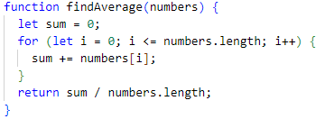

**THE PROBLEM**

There's a bug in the implementation of the findAverage function that causes it to **produce incorrect results** (it displays NaN)

**YOUR JOB**

Your task is to **identify and fix the bug** in the **findAverage** function to ensure that it correctly calculates the average of numbers in the array.

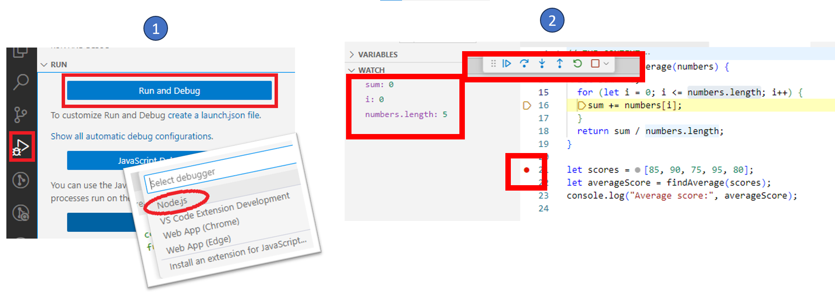

*For this exercise, you should launch VScode debugger and diagnostic the bug, step by step*

# EXERCISE 4

In this exercise you will need to work with 3 array functions: map, filter, reduce

<https://developer.mozilla.org/en-US/docs/Web/JavaScript/Reference/Global_Objects/Array/map>

<https://developer.mozilla.org/en-US/docs/Web/JavaScript/Reference/Global_Objects/Array/filter>

<https://developer.mozilla.org/en-US/docs/Web/JavaScript/Reference/Global_Objects/Array/reduce>

**YOUR JOB**

Complete the 3 functions with the corresponding code. *Everything should ft in 1 line!*

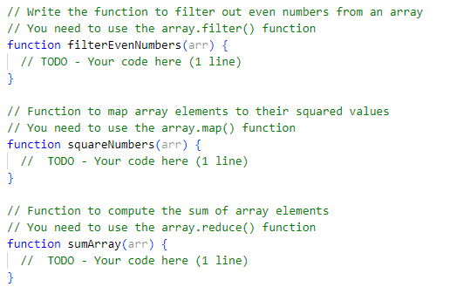

# EXERCISE 5

In the provided code, there's an array named students, containing objects representing students with their IDs, names, and grades.

let students = [

  { id: 1, name: "Trang", grade: "A" },

  { id: 2, name: "Hai", grade: "B" },

  { id: 3, name: "Linh", grade: "C" },

];

There's a function named updateStudentGrade() that takes three parameters:

* studentsArray the array of students)
* idToUpdate the ID of the student to update)
* newGrade the new grade to assign to the student).

function updateStudentGrade(studentsArray, idToUpdate, newGrade) { … }

**YOUR JOB**

Your task is to complete the updateStudentGrade function, following the steps.

*Note : You will need to use the following elements : array.findIndex(), spread operator*

**